- Cover Page
- Title of the Case Study- Bagless Education and No Homework at Home
- Theme/Area of Reporting Innovation/Best Practice- Bagless Education Policy and No Homework at Home - A move to the Future of Inspired Learning
- Name and Address of the School- Sou. Vijayadevi Yadav English Medium School, Peth Vadgaon.
- Name of the Principal- Dr. Sardar Jadhav
- Names of the contributing teachers and qualification-
- Dr. Sardar Jadhav
M.A., M.Phil., Ph.D., D.Litt., MBA, B. Ed., PGDPC, DSM
- Mr. Maruti Kambale
M.A., B.Ed.
- Mr. Sagar Pharande
M.A., B.Ed., DSM
- Contact Details- vp_ac@vyis.edu.in

- Table of Contents

Sr No. | Content
1. | Executive Summary
2. | Introduction
3. | Case Presentation
4. | Evidences of success
5. | Beneficiary Satisfaction
6. | Concluding Remark
7. | Glossary
8. | Certificate of originality by School Principal
9. | Certificate of originality by author
10. | NOC

- Executive Summary-
The sight of a small child lugging a colossal school bag is not uncommon in any Indian city. While digitalization of education, BAGLESS education and No Homework at Home concepts are adopted in a great futuristic way by Sou. Vijayadevi Yadav English Medium School, Peth Vadgaon. The aim of this concept is to provide the experience of stress-free and burden less education for students. Books are replaced by another set / PDF books / E books / Mobile App. Workbooks and Notebooks are replaced by loose sheets. Thus, the assets of school bag are A File (Collective), A School Diary & A Compass Box. Bagless Education endorses enthusiastic learners and is applicable from Grade 1 to 8.
The unique policies of ‘No Homework at Home’ and ‘Bagless Education’ are seemed fruitful with a lot of time for children to bond with their family members and exercise their curiosity to learn through experience. These policies help the children to spend time with their families, read story books and have discussions.

- Introduction-
“The education of even a small child does not aim at preparing him for school, but for life.” How true! Childhood is a time to learn, and have fun. Academics should not overshadow health. Carrying a larger-than-required school bag puts an unnecessary strain on the child’s back, affecting their musculoskeletal system adversely- moreover if the bag is carried by a single strap on one shoulder.
India has a great tradition of Gurukul Education System where the disciples were free to chase their aspirations in a tension free atmosphere. They were taught by great sages in the laps of nature keeping the imagination and curiosity of the learner free of any burden. As the time changed, so did the education system. The students were found carrying the heavy loads of school bags on their back that caused tremendous physical and mental stress on the budding blossoms.
Deeply grieved by this great concern the Principal of Sou. Vijayadevi Yadav English Medium School, Peth Vadgaon, Dr. Sardar Jadhav came up with unique thoughts of ‘Bagless Education’ and ‘No Homework at Home’. This proved to be a great boon to all the students, parents and teachers. The burden from the delicate shoulders was shifted from students to the classrooms giving liberty to the learners to spend quality time with their family and friends.
Case Presentation-
- Identification of the problem/challenging situation/issue to be resolved-
The Children’s School Bags (Limitation on Weight), Bill of 2006 states that the weight of a school bag must not exceed more than 10% of the child’s bodyweight. It also directs respective State Governments to ensure that schools provide lockers for the students, ensure that schools adhere to the standards of measurements for bags, and students use both straps for carrying bags.
There is ample of statistical data available that estimates 68% of pre-teen Indian school children might suffer from mild back pain, which can develop chronic back pain and later into a hunchback. In addition, various surveys have noted that over 88% of the children, in the age group of 7-13, carry more than 45% of their weight on their backs. The findings also include facts such as most students mandatorily carry over 15 to 20 textbooks and exercise copies daily, together with sports kits and other equipments on certain days. The scientific study says that children aged 8-15 should not carry more than a three kg weight on their back, because it affects their soft, developing spine.
- Analysis of the problem-
The Principal Dr. Sardar Jadhav had detailed analytical study of this major concern. He strongly believed that school needs to be fun, enriching environment, which children should not need to carry inhuman amounts of eight on their backs, to attend. Summarized hand-outs of textbook concepts keep the students load-free, literally and also allows them to concentrate on the concept at hand. For example, if they are learning about Collective Nouns one day, why carry the entire burdensome grammar book and the language notebook that day?
A detailed planning for the reduction of the school bag weight was done with all possible facts and problems that it might cause. Meetings after meetings of the school management were conducted debating and discussing about every minute thing. Such a revolutionary concept does not materialize overnight. It needs proper plan and execution of the plan. Of course the implementation of such innovative concept is not an easy task. It needs a thorough guidance to the students, parents and teachers alike.
- Objectives-
- Bring relief to the tender shoulders
- Promotion of physical growth
- Reduction of spinal problems
- Develop good body posture
- Provide independence to carry own bag
- Give a joyful learning experience
- Planning done-
- Students and Teachers will be trained about the practical implementation of the very thought behind the core concepts of ‘Bagless Education’ and ‘No Homework at Home’
- Parents will be convinced in a specially scheduled orientation session.
- The set of Textbooks will be kept in the school itself in the cabinets provided.
- Workbooks and Notebooks are replaced by loose sheets.
- Each subject worksheets will have a different colour.
- Each subject worksheets will be maintained in a separate file.
- All the worksheets will have the basic information of the student such as Name, Grade, Division, Roll No, Date, Worksheet No, Student’s Sign, Parent’s Sign, Teacher’s Sign, etc
- The homework that is to be done at home will be completed in the school itself at the end of the day under the supervision of teachers.
- All the subject files will be kept in the classroom in a separate cabinet provided to each student. (under lock and key)
- Everyday’s completed worksheets will be sent home for parent’s acknowledgement in a Collective File.
- The assets of school bag are A Collective File, A School Diary & A Compass Box.
- The weight of the school bag is not more than 500 grams.
- Bagless Education is applicable from Grade 1 to 8.
- All the subjects files will be sent home for detailed revision before Half Yearly and Annual Exam.

- Success Criteria and possible alternatives decided-
Success Criteria -100%
Possible alternatives decided-
- A thorough plan was made.
- The school bag was weighed again and again to make sure it’s weight doesn’t exceed more than 500 grams.
- Parents orientation with practical demo of File Management.
- File management will be crucial and confusing task initially but can be resolved easily with sufficient practice.
- Implementation-
- All the students and teachers were trained about the practical implementation of the concepts of ‘Bagless Education’ and ‘No Homework at Home’.
- Parents were convinced and briefed about the same.
- A set of files including Subject Files, Test File, Collective File was provided to the students.
- Each subject worksheet colours were specified such as English-Orange, Hindi-Green, Sanskrit & Marathi- Blue, Maths- Yellow, Science- Pink, Social Studies- Light Grey, Computer- Dark Grey.
- The homework that is to be done at home is planned well and is easily completed in the school itself at the end of the day under supervision of teachers.
- The completed homework and class work is sent home daily in the collective file for parent’s acknowledgement.
- Specially designed cabinets for each student with a facility of lock and key, and name sticker were brought to the classrooms.
- A set of Textbooks was kept in the school itself in the cabinets provided.
- Parents may use another set of books / PDF books / E books / Mobile App for the revision or extra studies at home.
- The weight of school bag is checked regularly during the school hours.
- The Subject HODs and Section Coordinators make sure the smooth functioning of the File Management and suggest remedies in case of confusion (if any).

- Challenges faced in implementation-
- Sometimes students carry the Subject Files at home by mistake.
- At times parents make photocopies of the worksheets sent home along with the students for acknowledgement.
- Some parents still believe in the traditional method of notebooks and textbooks to be carried in the school bag.

- Resources involved-
- Human Resources- Students, Parents, Teachers, Subject HODs, Section Coordinators, Vice Principal, Principal.
- Material Resources- Different Colour Worksheets, Files, School Bag, etc.
4. Evidences of success-
a. Photographic evidence-
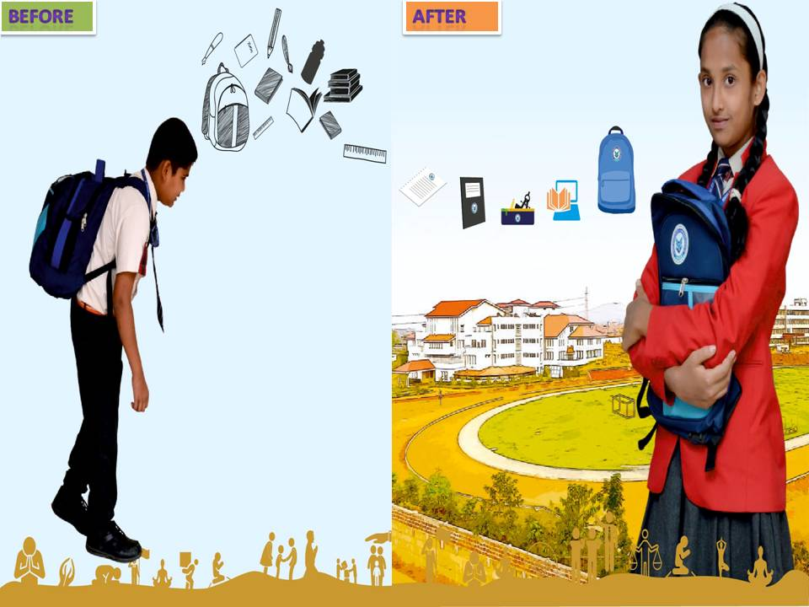
1. Benefits of Bagless Education-

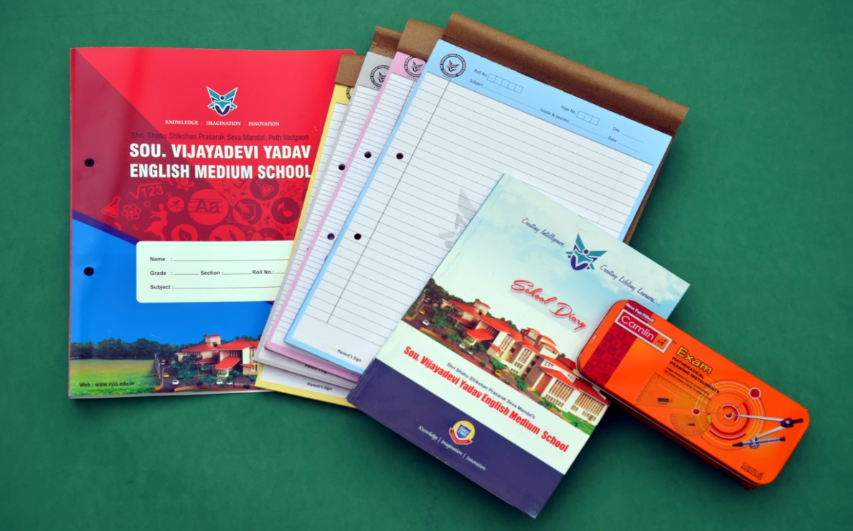
2. Assets of the School Bag-

3. Cabinets in the Classroom-
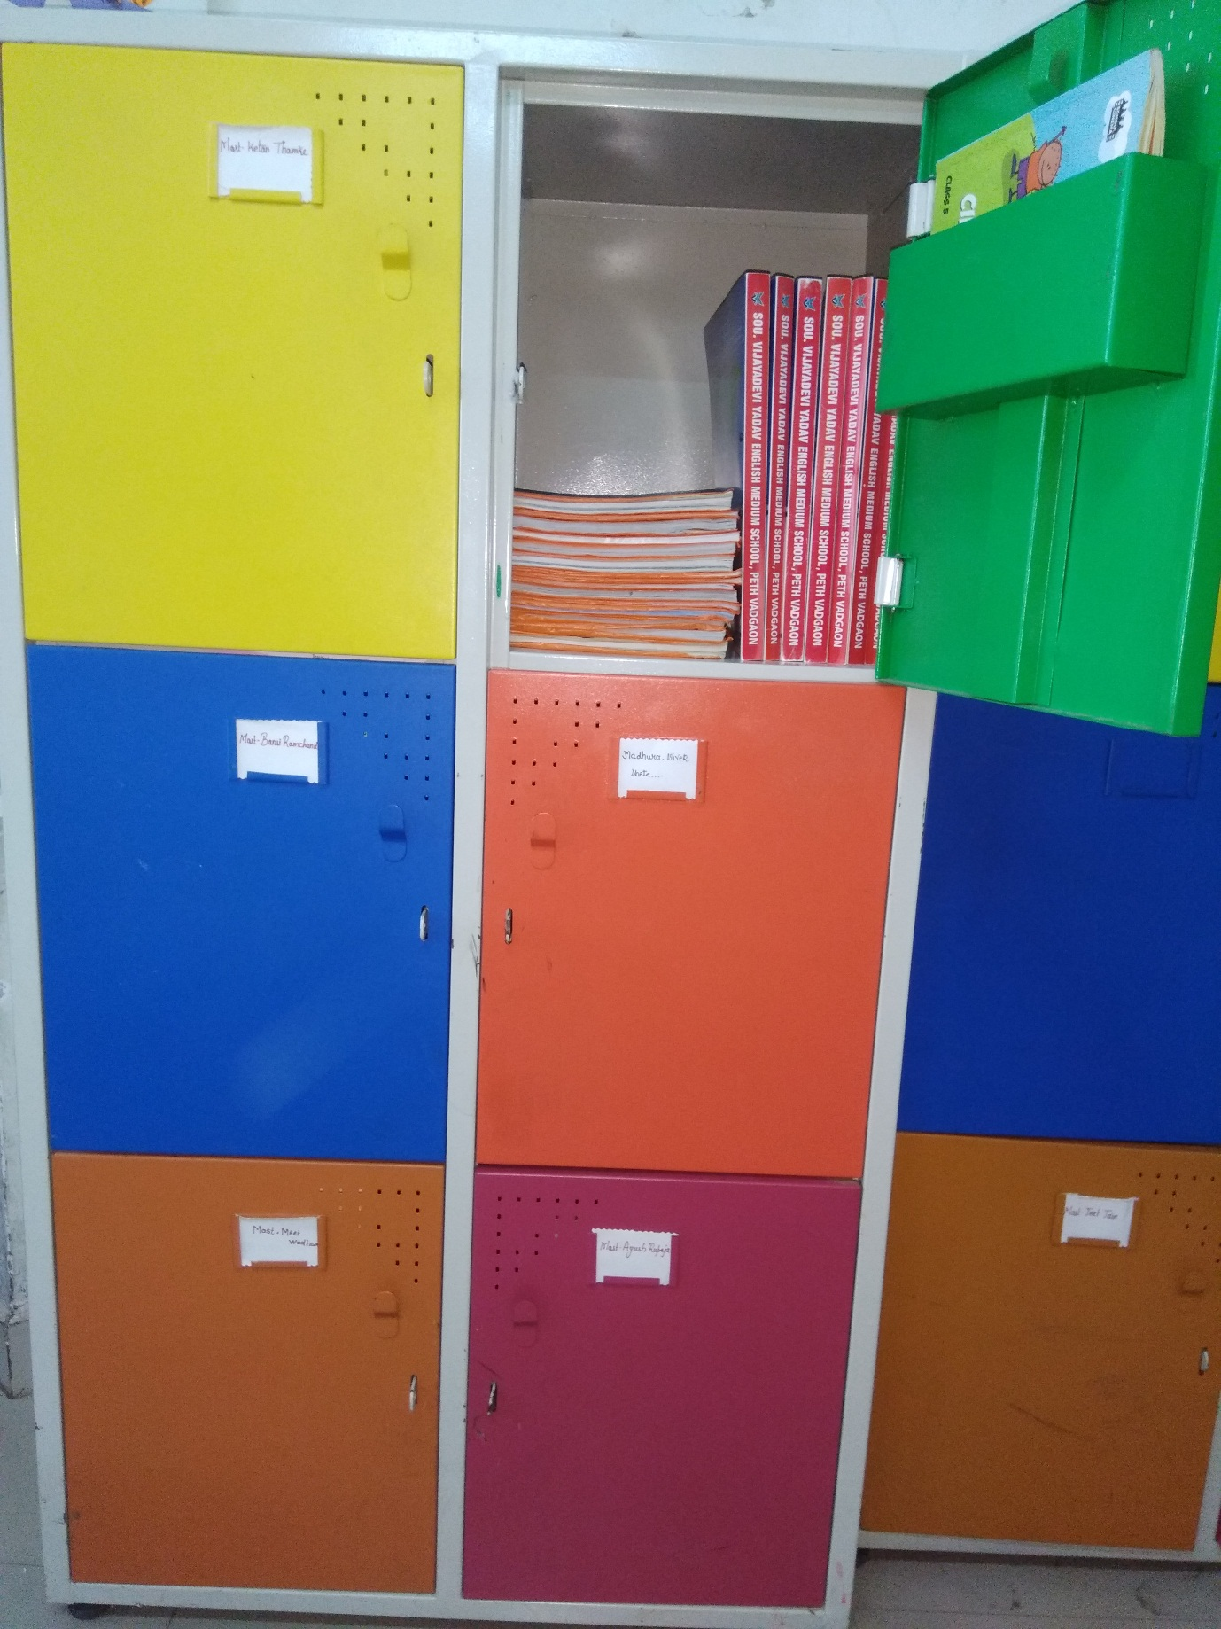

5. Beneficiary Satisfaction-
1. PTA President’s Feedback-
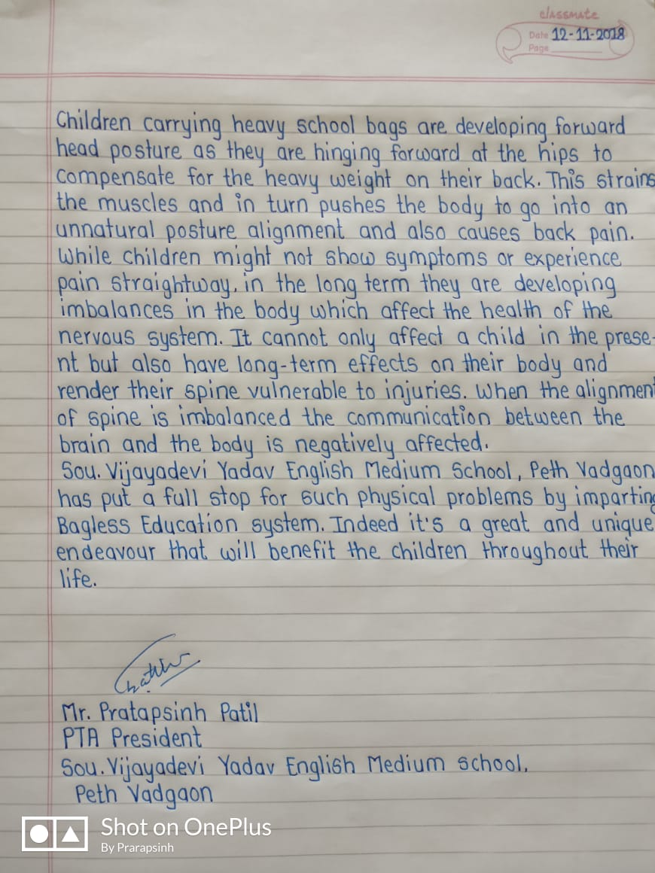

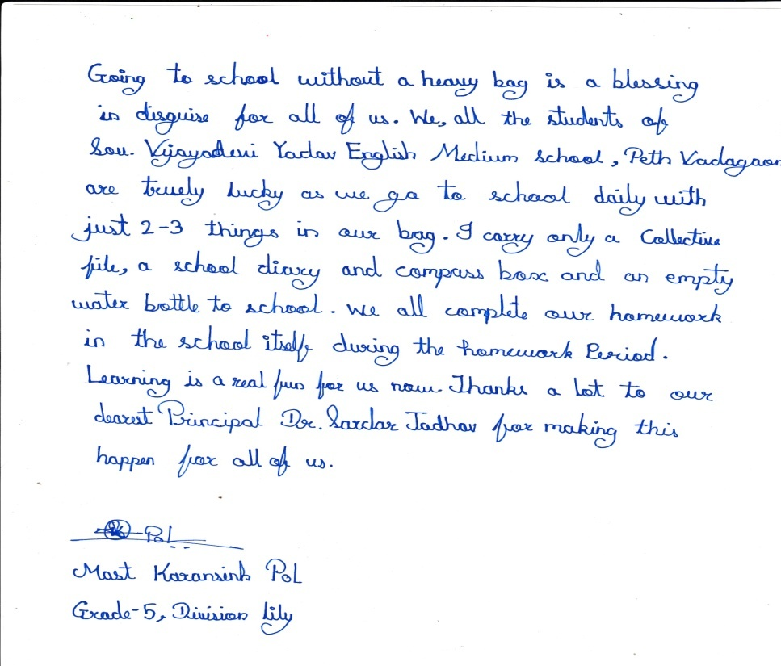
2. Student’s Feedback-

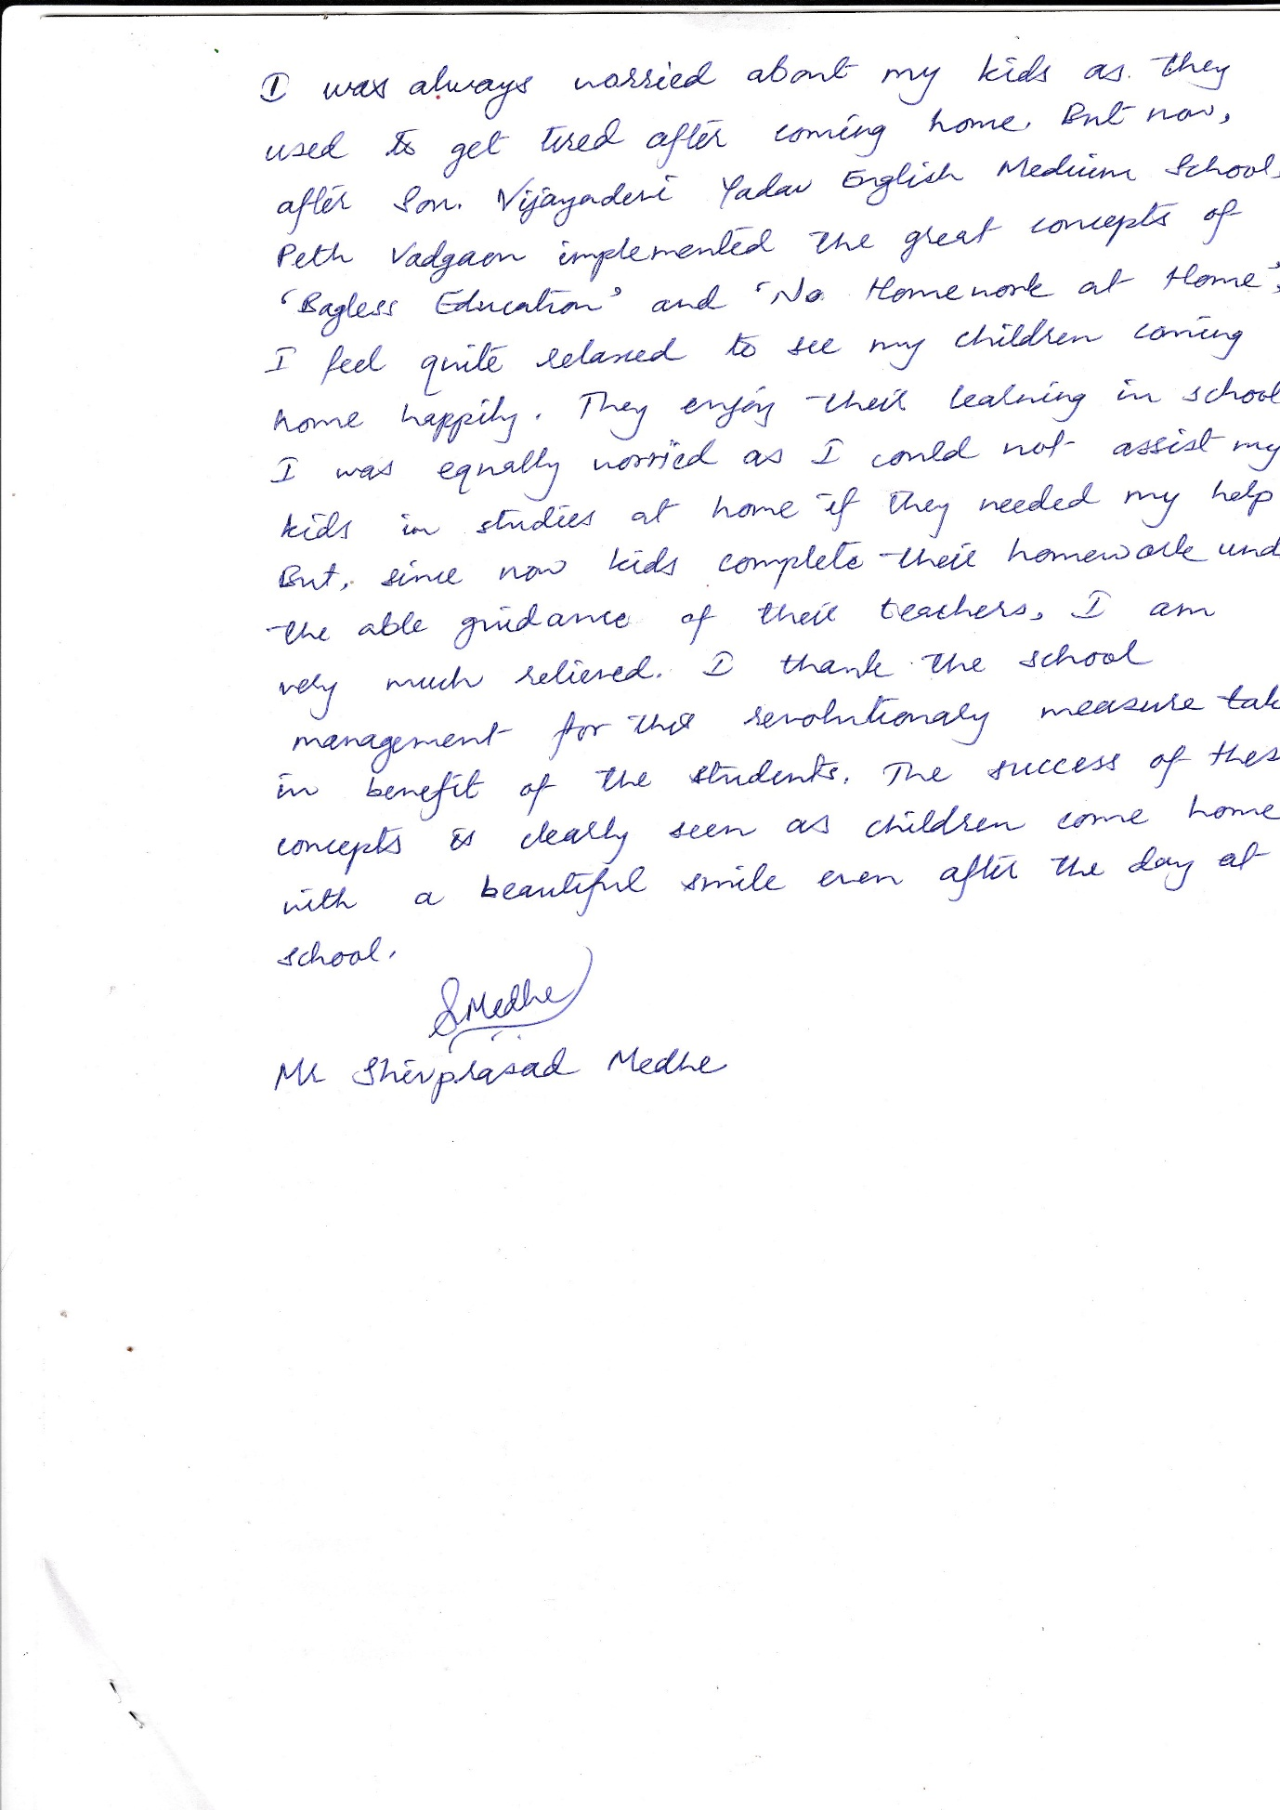
3. Parent’s Feedback-

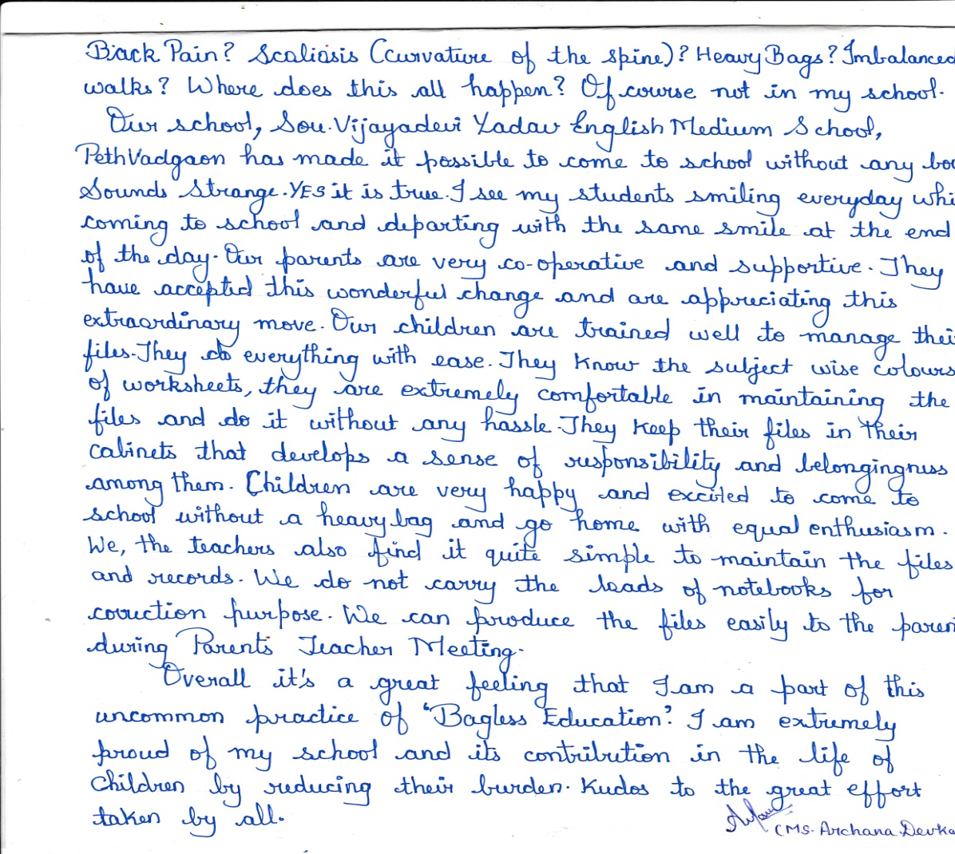
4. Teacher’s Feedback-

6. Concluding Remarks-
Sou. Vijayadevi Yadav English Medium School, Peth Vadgaon has its motto to create excellence and create lifelong learners. “Bagless Education” and “No Homework at Home” is an innovative step taken by the school much before the government makes it compulsory for the schools to take initiative to reduce the burden of students. All the children are enjoying the learning process due to this unique endeavour. We are practicing these policies since last three years successfully.
This and many such initiatives make the school one of its type in achieving its vision to unify the whole world as one family so as to emerge cultured, responsive, creative and successful global citizens who are ready to make important contribution to the world around them.

7. Glossary-
- Bagless Education- A learning process where the school bag of each student does not weigh more than 500 grams.
- Worksheet- A loose page of specific subject wise colour used for writing instead of the traditional notebook page. Each worksheet has the basic information of the student such as Name, Grade, Division, Roll No, Date, Worksheet No, Student’s Sign, Parent’s Sign, Teacher’s Sign, etc
- Subject File- A file where all the worksheets are maintained in order of a particular subject with an index.
- Collective File- A file with some worksheets of different subjects including class work and home work completed during the day. It is to be taken home for parents acknowledgement at the end of the day in the school bag. It includes all the subject worksheets that will be brought back and arranged in each subject file systematically on the next day.
- File Management- Arranging the worksheets in proper order in each subject file.
- Parent’s Orientation- A guiding session for the parents about the school activities, plans and procedures. It’s an open platform for the parents to clear their doubts about planning and implementation of innovative initiatives undertaken by the school.

8. Certificate of originality by School Principal

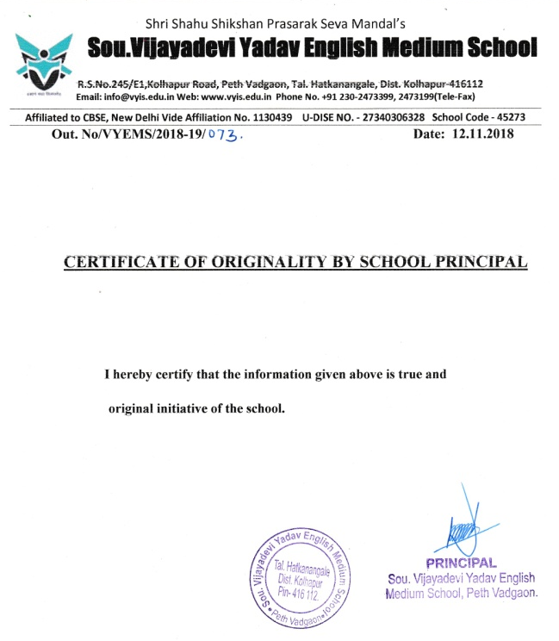

9.Certificate of originality given by the author-

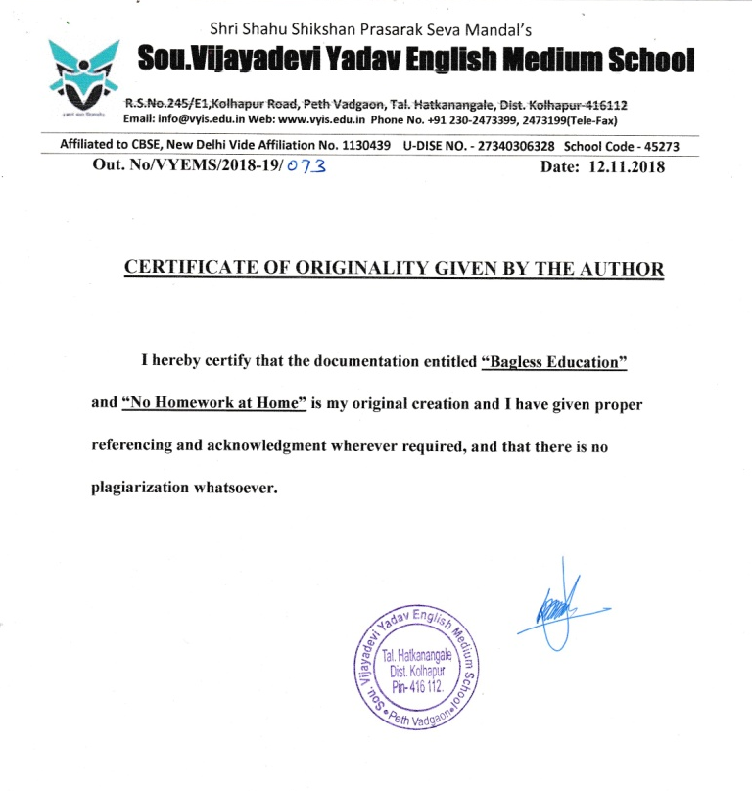

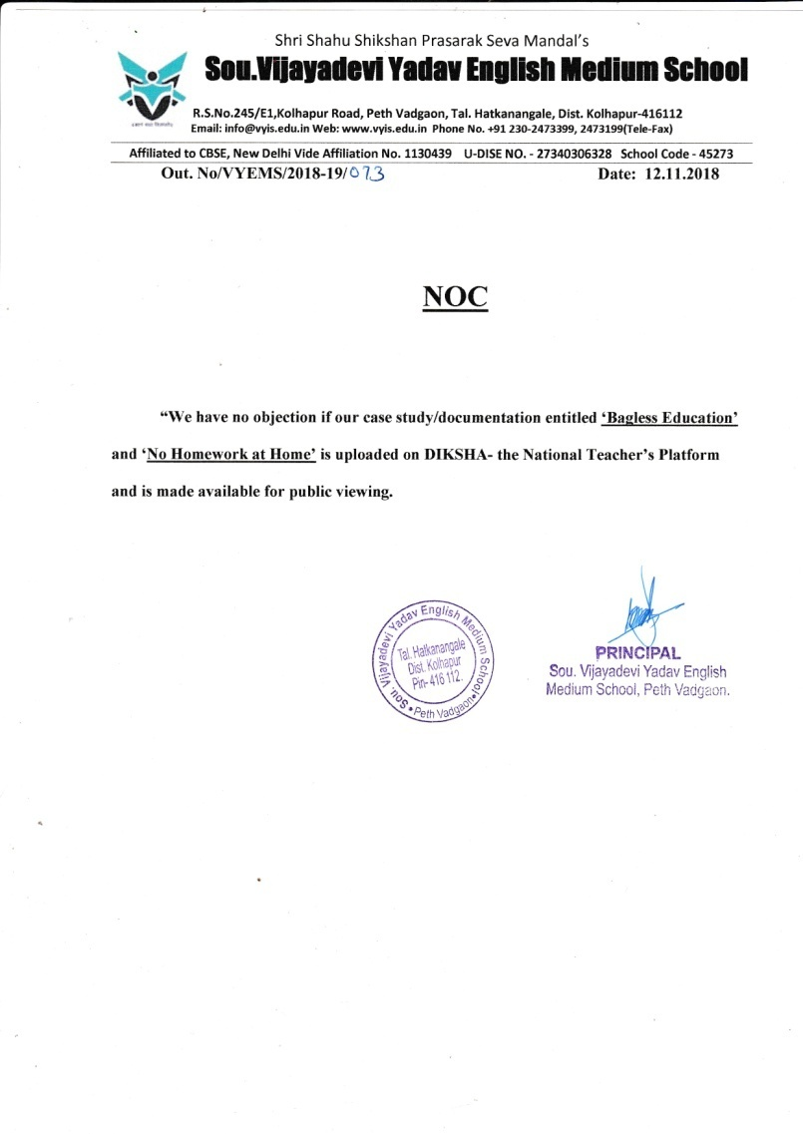
10. NOC

